**Spring Boot Application Template/user-api project**

This Project has the backend code

1. to register user into the system with my first name, last name, email.
2. to get the list of all the users in the system.
3. to search a user by email and return the details.

File Structure :

JAVA Files :

1. UserAPIApplication.java – This is the main Spring boot application File to be run as a “Java Application” for starting the project flow .
2. UserController.java– This is the rest API Controller which accepts the rest call from external source(or the UI) and provides the response.
3. UserService.java - This is the business service class which communicates with the repository for user data
4. UserInterface.java – Spring Repository which extends the CrudRepository.
5. UserData.java - Entity object for DB persistence

Application.properties:

Server port is initialized to 9005. If the application needs to run in a different port kindly update property

Server.port

DB :

This application uses the embedded apache derby database(as a part of spring boot project). Hence no DB configurations are specified in the application properties.

Server :

This application is deployed in the embedded tomcat server and runs on port 9005.

APIs Exposed:

1. **UpsertUser** API to update user if exists else create a new

Rest URL : http:// <ip/localhost> :9005/UpsertUser

Screenshot from PostMan

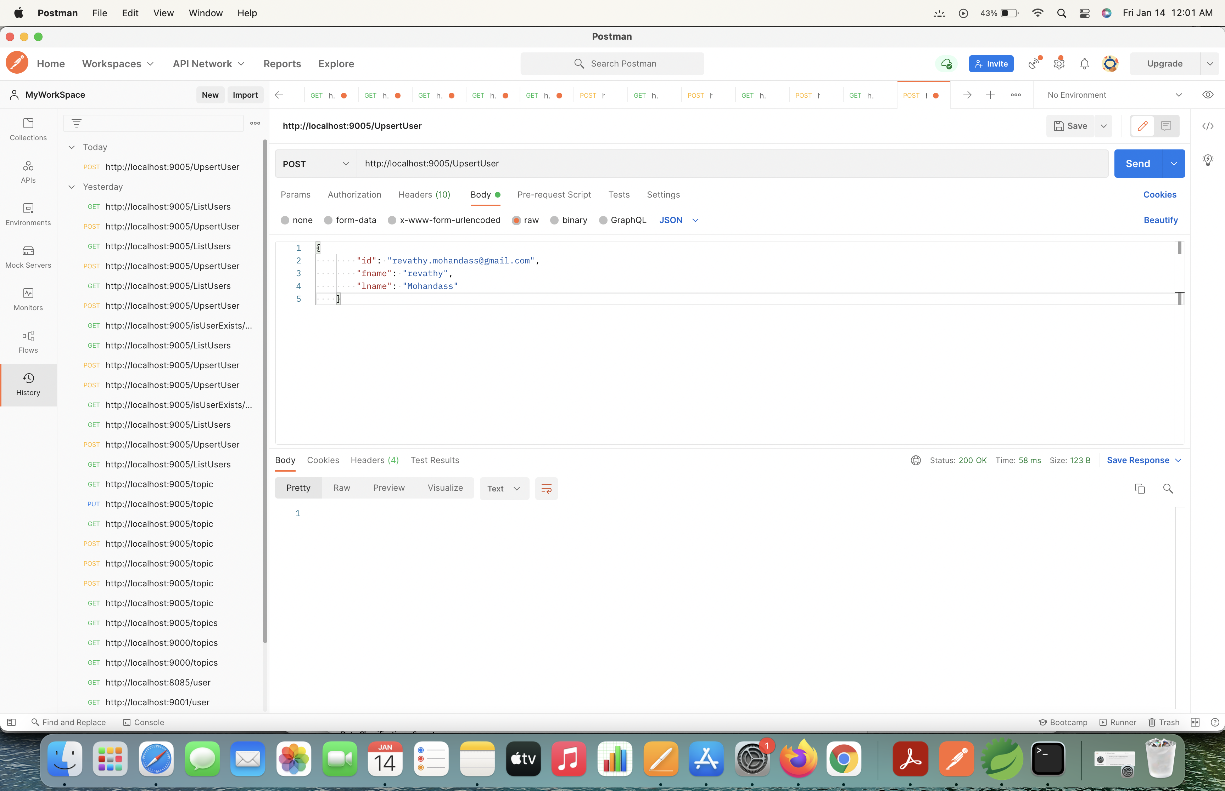

1. **IsUserExists** API which takes input as email and returns appropriate status

Rest URL : http://<ip /localhost>:9005/isUserExists/<email-id>

Screenshot from PostMan :

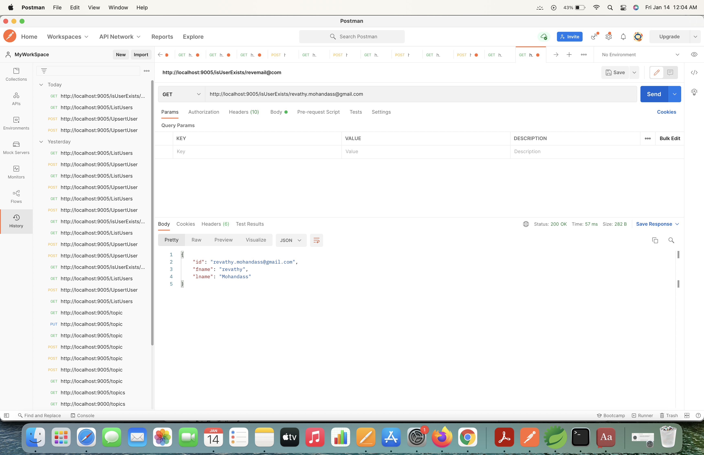

1. **ListUsers** API to return list of all users

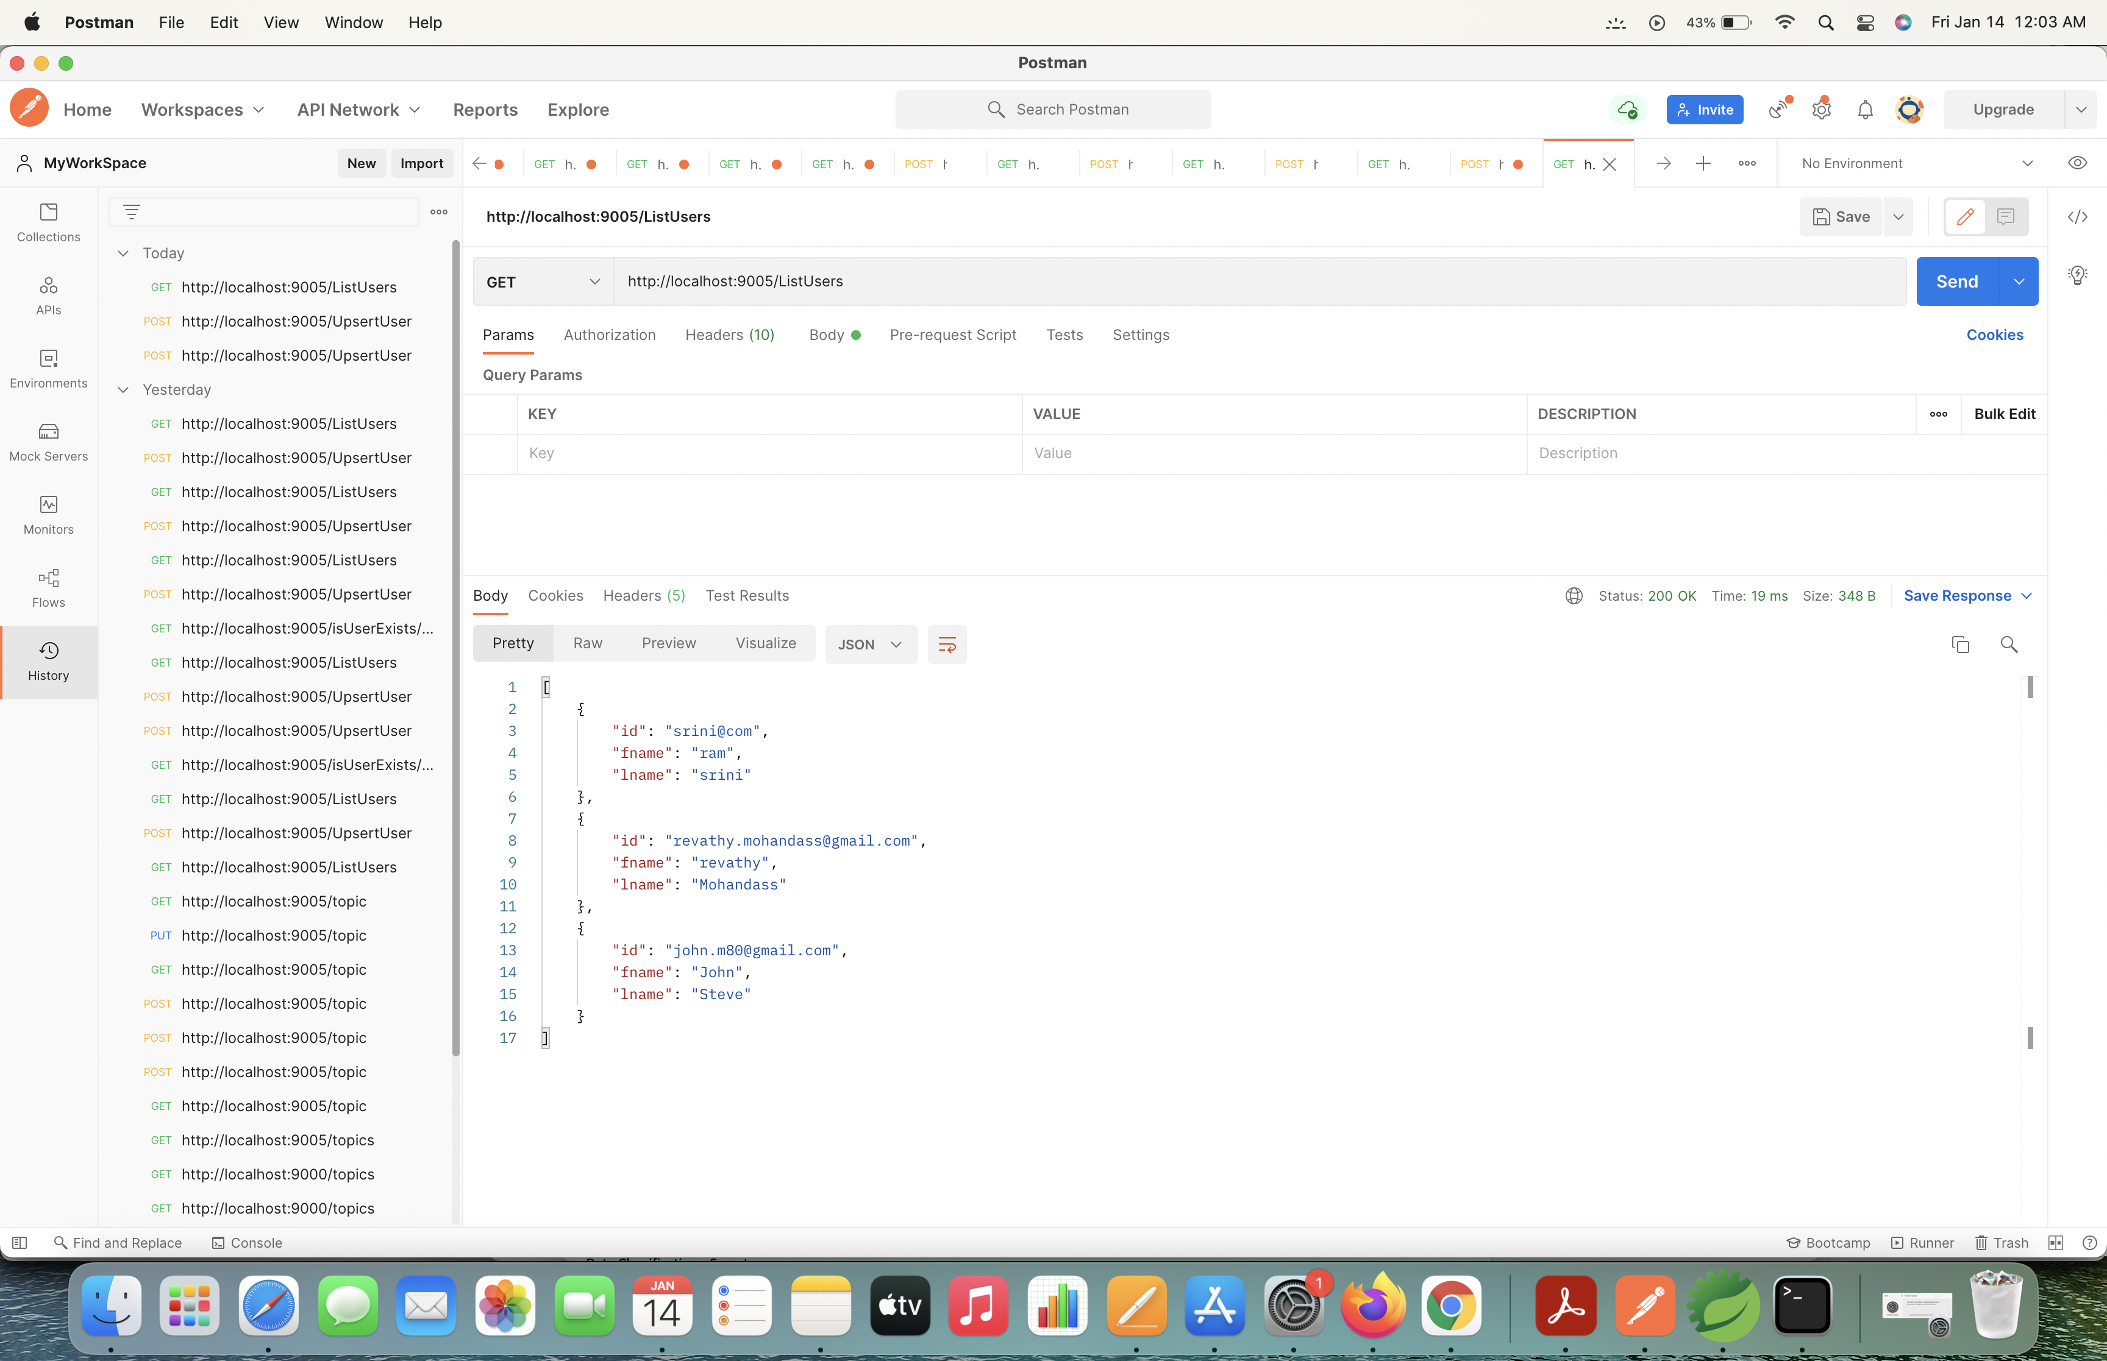

Rest URL : http://<ip/localhost>:9005/ListUsers

Screenshot from PostMan :

To Do :

This project needs UI development to invoke the rest API services.

Only the rest-api's are developed and can be tested with PostMan.